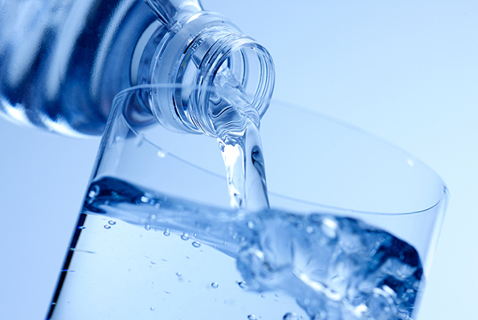
Maintaining Hydration

Staying well hydrated makes everyone feel better. Every cell in your body needs water to work properly. Water regulates our body temperature, maintains blood pressure, gets rid of toxins, lubricates joints, and helps transport and digest the food we eat. While the standard rule of 64 ounces a day works for most, it may not be enough for some. Divide your weight in pounds by half and aim for that many ounces of fluid each day.

To avoid becoming dehydrated, your body needs to be constantly resupplied with fluids. Dehydration develops when you haven’t taken in as much water as your body has lost in your sweat, urine or stool. Some patients will also lose fluid through any drains or tubes they might have.

When you are dehydrated, everything is worse! Signs of dehydration include:
- Making less urine, as your kidney tries to hold on to fluid, concentrating your urine into a deeper yellow, often becoming the color of apple juice.
- Increasing fatigue or lack of energy; sometimes including muscle weakness.
- Headache and increased nausea or pain
- Constipation, as the colon also tries to remove water from your stool to keep you hydrated
- Dizziness and feeling light-headed, especially when you move from sitting to standing. Your body may be having trouble maintaining your blood pressure.
- Excessive thirst and dry mouth; though this warning sign is less reliable as we get older

Drinks that are primarily water, including sport replacement drinks, herbal teas, flavored water, and broth work best. Caffeinated beverages such as soft drinks, tea, and coffee increase urination slightly, but still provide hydration. Many of the foods we eat also hold a lot of water, including most fruits and vegetables.

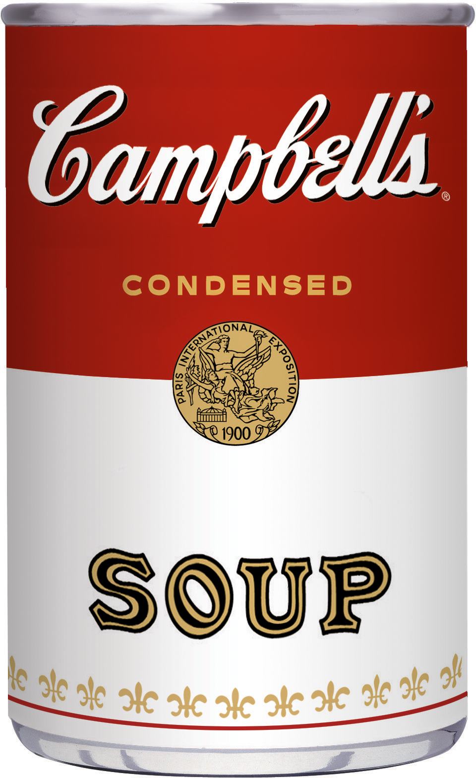
91-100% Water:
Water, milk, sports drinks, soup, watermelon, strawberries, broccoli, lettuce, tomatoes, cucumbers
Popsicles, jello, or anything that becomes a liquid at room temperature.

80-90% Water:
Fruit juice, cantaloupe, oranges, apples, pears, grapes, peaches, gelatin

70-79% Water:
Peas, frozen yogurt, bananas, some fish, eggs, casseroles

GOAL: Getting in enough fluids without interrupting your sleep at night!
32 ounces by the time lunch is finished
Another 32 ounces through the afternoon and dinner.
Helpful strategies for increasing fluid intake

- Have a glass of water before or after you brush your teeth
- Drink something on your drive to work each day.
- Drink 12 – 16 ounces every two hours through the day. By evening, you’ve finished what you need and you won’t worry about evening fluids causing you to get up too much at night.
- Set alerts on your computer to remind you of an “appointment” with your water bottle.
- While you watch television, keep a glass nearby and pick it up at every commercial. By the end of the program you’ll be finished.
- Include a glass of tea, milk, or juice with your meals
- Choose a cup of yogurt or a piece of fruit for an afternoon snack
- Add a slice of lime, lemon, or orange to water for flavor, or even a couple ounces of juice. Check the website, www.infusedwaters.com for other recipes to help water taste better.
- Carrying a water bottle with you lets you take advantage of down time while waiting in lines.
- Check out the free apps: “waterlogged” or “drink water reminder”

Special Circumstances:
- Always replace any fluids lost with diarrhea, by drinking an extra cup for each loose bowel movement.
- Pack a cooler with drinks to keep near your chair, if fatigue keeps you out of the kitchen.
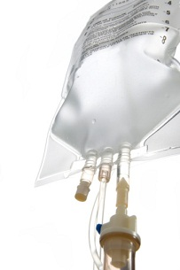
- When exercising, make sure you drink water/fluids before, during and after your workout. Some examples include Vita Coco Coconut Water, O.N.E. Coconut Water, Vitamin Water and Vitamin Water Zero, Ion 4, Powerade Zero, BomDia Coconut Splash, Gatorade-G2 Natural
- Drink extra fluids after being outside on a hot day.

If you have gotten very dehydrated, talk to your doctor about whether getting fluids intravenously (IV) would be helpful.

Watermelon Juice
Watermelon- 1 Cup chopped roughly and chilled
Sugar/Honey- 1 tsp
Lemon Juice- 1 tbsp
Salt- a pinch

In a mixer add sugar and lemon juice to chunks of watermelon and blend it.. Refrigerate for a while and serve chilled. Do not add water as watermelon itself is high in fluid.

Watermelon, Pineapple, and Peach Smoothie
Watermelon- 2 Cups
Crushed Pineapple, drained well- 1 Cup
Peach Yogurt- 2 Cups
Ground Cinnamon- 1 dash
Vanilla Extract- ½ teaspoon

Blend Ingredients together in a blender until smooth and serve immediately.


Colleen Gill, MS, RD CSO (2008-2025) Nutrition Foundations
Registered Dietitian 303-810-8612 colleen@nutrition-foundations.com

